**DocuSign Memorandum of Understanding**

I / We have read and understood all presented documents before the commencement of execution and confirm:

1. I am / we are the Borrower(s) named in the loan documents.
2. I / we understand the nature and effect of the loan documents.
3. I / we have been given the opportunity to obtain independent legal and financial advice.
4. I consent to receiving and signing the loan documents electronically.
5. I / we sign the loan documents freely, voluntarily and without pressure.

<<rs_directors>>

|  |  |
| --- | --- |
| \signature1\ |  |
| **<<GUARANTORNAME>>** |  |

<<es_directors>>

**Borrower(s) Checklist**

|  |
| --- |
| **Documentation** |

Please ensure you have the complete documentation listed below, that you have read them and if needed obtained such independent advice as you require before execution. You must complete the following actions:

**Read Only **

|  |  |
| --- | --- |
| **1.** | **Credit Guide** |
| **2.** | **Loan General Terms** |
| **3.** | **Mortgage Common Provisions** |

**Read and DocuSign  **

|  |  |
| --- | --- |
| **4.** | **Loan Agreement – Loan Offer** |
| **5.** | **Mortgage** |
| **6.** | **Privacy Policy Collection Notice** |
| **7.** | **Guarantee & Indemnity: Holding Trustee** |
| **8.** | **Guarantee & Indemnity: SMSF Members** |
| **9.** | **Acknowledgement by the Guarantor(s)** |
| **10.** | **Disbursement Direction Authority** |

**Read, Complete and DocuSign   **

|  |  |
| --- | --- |
| **11.** | **Direct Debit Authority (please note an Australian Bank account must be nominated on the Direct Debit even if you choose to use the offset account option)** |

**The following documents will be emailed to you separately to print, wet sign and post to us:**

  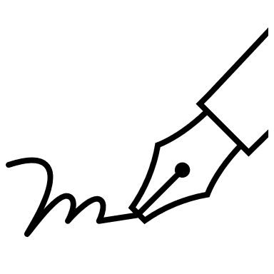 

|  |  |
| --- | --- |
| **12.** | **Solicitors Certificates of Legal Advice - <<Guarantor2Fullname>>** |

**Upload **

|  |  |  |
| --- | --- | --- |
| **13.** | Bank Statement of Nominated Direct Debit Account showing Account Name, BSB and Account Number. | /BankStmt/ |
| **14.** | **Policy of Insurance**  The policy must specifically note the following:   1. <<PROPDET1MORTGAGORS>> as the insured party; 2. **Source Funding Pty Ltd I 622 815 294** as First Mortgagee with minimum cover **$<<INSURANCEAMOUNT>>.**   The Policy must provide indemnity on a **full replacement and reinstatement** basis and to cover all risks required by the Lender including fire, storm and tempest. The policy must also include public liability cover of not less than $2,000,000.00.  **Please note that Cover Notes and Certificates issued by Brokers are not acceptable.** | **/CoC/** |
| **14.** | **Copy of current Strata/Body Corporate Insurance**  **Please note that Cover Notes and Certificates issued by Brokers are not acceptable.** | **/CoC/** |
| **15.** | **Special Conditions Documents** (if applicable) |  |

|  |
| --- |
| **Search and Settlement Requirements** |
| ***\*\* You or your Solicitor are to provide these \*\**** |

|  |  |
| --- | --- |
| **16.** | The **Transfer** created in PEXA |
| **17.** | Copy of Land Tax, Rates and Water searches |

|  |
| --- |
| **Satisfaction of Special Conditions** |

<<LOANSPECIALCONDITIONS>>

I have read and understand the above Special Conditions.

|  |  |  |  |  |
| --- | --- | --- | --- | --- |
| <<rs_directors>>   |  |  | | --- | --- | | \signature1\ |  | | **<<GUARANTORNAME>>** |  |   <<es_directors>> |
|  |

**Submit **

Once you have read, completed and DocuSign all the documents in the loan pack, click the ‘ **Finish ’** button. You’ll be emailed a link to access a completed copy of your documents – please

download the documents, to keep for your records, within seven (7) days.